LeetCode Multiple Choice Learning App Design
  - V1 product and technical specification

Proposal
Build a web app that helps learners recognize algorithmic patterns, compare solution tradeoffs, and practice weak topics through short multiple-choice quizzes. The initial question bank focuses on Amazon-tagged problems. A dolphin mascot guides the experience, while a dashboard and weekly analysis show progress and explain what to practice next.
V1 uses a Next.js web app, a FastAPI backend, PostgreSQL, and an external LLM API. Application code grades answers, computes analytics, and recommends questions by traversing topic relationships. The LLM prepares draft choices, delivers grounded Socratic feedback, and turns computed performance statistics into readable analysis.

Product scope
Included in V1
Google login and editable learning profile
Four visual approach cards per quiz, with time and space complexity
Daily practice, review, extra practice
Adaptive recommendations and performance analysis

Learning contract
Each item asks the learner to choose the best approach. V1 uses single selection and exactly one accepted choice. A functionally valid but less suitable solution is labeled “valid but suboptimal” not described as producing an incorrect answer. If two choices tie under the stated assumptions, revise the prompt or choices before publication. Mastery measures evidence of approach recognition, not proof of coding ability.
There are 3 things user can do daily: both are done using code not llm
1. Daily questions: number can be set on profile
2. Daily reviews: Use Ebbinghaus forgetting curve
E.g. questions solved on day 0 should be reviewed on day 1, 2, 6, 31; questions solved on day 1 should be reviewed on day 2, 3, 7, 32, etc
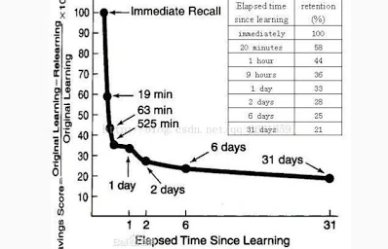
3. Recommend on extra question based on user performance on that day. Recommandation mechanism will be discussed later

1 Core user loop
User login -> practice mode: take daily quiz -> review mode: review daily quiz -> optional: continue to practice on recommanded questions, watch performance matrix
The backend update performance once user exit practice/review mode

2 App pages and interaction design
Page | Content and behavior
Login | Google sign-in, concise product explanation, privacy information, and clear retry behavior for canceled or failed sign-in.
Profile | Google-derived name and avatar; editable display name, timezone and daily goal
Home and daily tasks | Dolphin greeting; saved daily practice and review set; daily goal and streak; resume an unfinished quiz
Quiz | Problem and criterion; four visual approach cards; submit state; verified result; Socratic explanation after submitting an answer (right or wrong); answer reveal and next question.
Dashboard | Performance:  1. Overall accuracy per topic on bar chart  2. Questions per day line chart  3. Accuracy on topic per week bar chart

3 Architecture and service boundaries
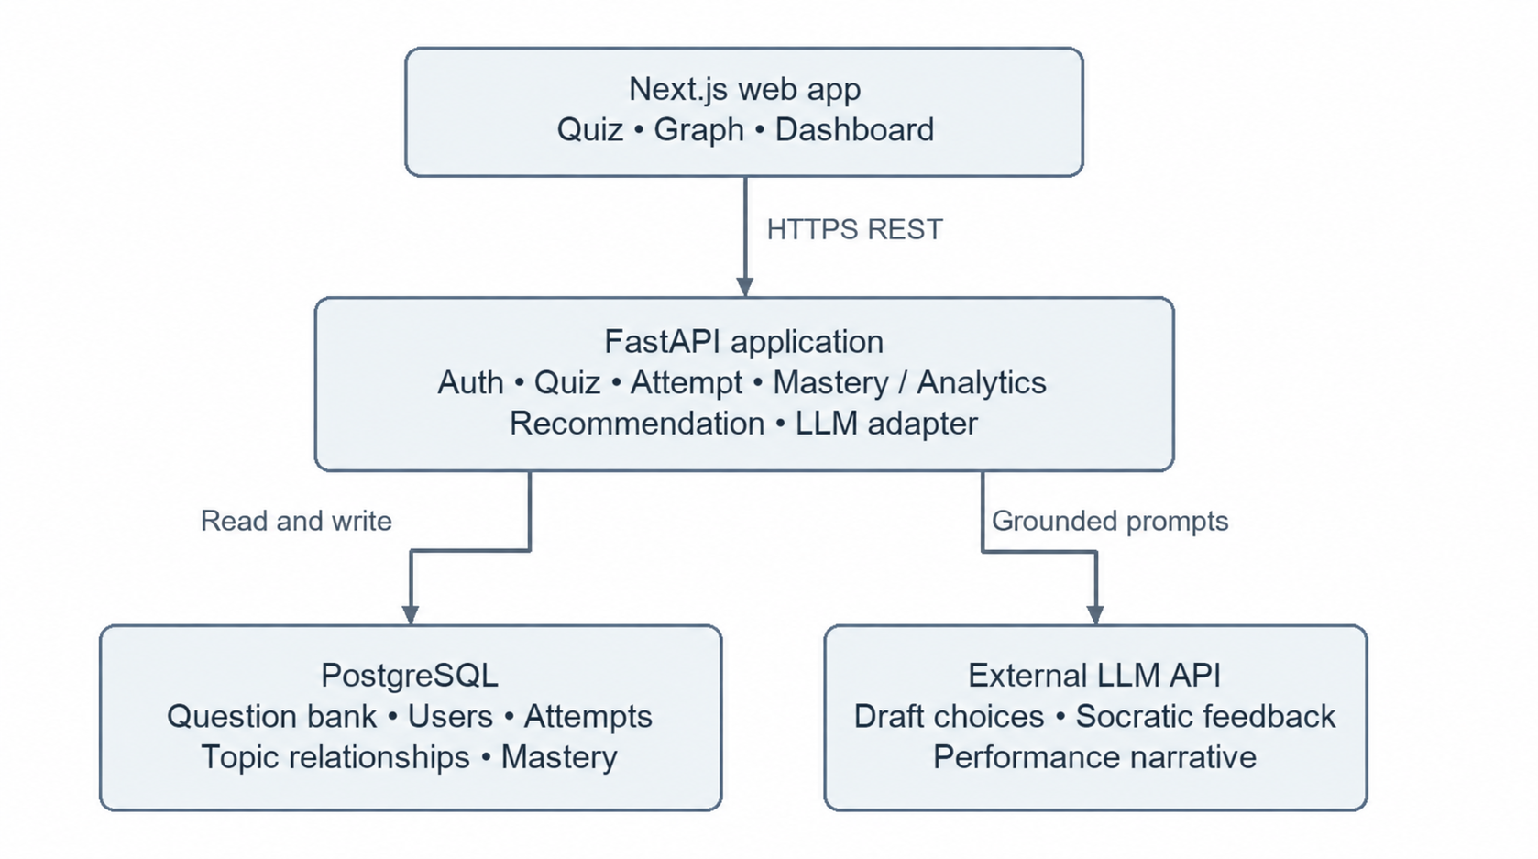
Google supplies the identity flow; FastAPI owns the application session and authorization. Serve the frontend and API through a common origin where practical to simplify cookie and CSRF handling.
Module | Responsibility
Auth | Validate Google identity, create or find the user, issue and revoke application sessions, enforce ownership and administrator access.
Quiz | Read published question versions, create quiz instances, randomize choice order, and deliver answer-free question payloads.
Mastery and analytics | Compute topic evidence, confidence and period aggregates. Provide versioned snapshots as the source of truth for charts and narratives.
Recommendation | Traverse PostgreSQL topic edges, apply eligibility rules and deterministic ranking, and record explanations and algorithm versions.
LLM | Build minimal grounded prompts; call the provider; validate structured output; manage bounded retries, costs, versioning and reviewed fallbacks.

4 Database
PostgreSQL in production; SQLite for zero-setup local development (same SQLAlchemy models). Tables are created and the pilot question bank is seeded idempotently on startup. All times are stored in UTC; “local date” columns use the learner’s profile timezone so a day starts at the learner’s midnight.
Table | Key columns | Purpose
users | google_sub (unique), email, name, avatar_url, display_name, timezone, daily_goal, is_admin | Identity from Google plus editable profile fields.
auth_sessions | user_id, token_hash, expires_at, revoked_at | Application sessions. Only a SHA-256 hash of the cookie token is stored; sessions last 30 days.
topics / topic_edges | id, name, position, x, y / (from_topic_id, to_topic_id) | Topic roadmap (section 7). An edge means “from” is a prerequisite of “to”. x/y hold the roadmap layout.
questions | slug + version (unique), status, lc_number, title, difficulty, summary, example, criterion, hint, source_url | Immutable question versions. The summary is original text; the full problem lives at source_url.
question_topics | question_id, topic_id, is_primary | One primary topic per question (used for charts) plus optional secondary topics (used for mastery).
companies / question_companies | name / question_id, company_id, provenance, observed_on | Company tags with visible provenance and observation date.
choices | question_id, position, label, detail, time_complexity, space_complexity, visual, verdict, explanation | Exactly four per question. verdict is optimal, suboptimal (valid but suboptimal) or incorrect; exactly one is optimal. visual is a key for a safe SVG template. explanation is the Socratic reason.
quiz_sessions | user_id, mode (daily | review | extra), local_date, question_ids, choice_orders, reasons, finished_at | A saved quiz. Daily and review sessions are unique per learner per local day. Choice order is shuffled once and stored.
attempts | user_id, session_id, question_id, choice_id, is_correct, mode, local_date | One graded answer per question per session (unique), so resubmits are idempotent.
review_items | user_id, question_id, stage, due_date, completed_at | Forgetting-curve schedule: four stages created on first answer, due on day +1, +2, +6 and +31.
user_topic_mastery | user_id, topic_id, attempts, correct, mastery, confidence | Performance snapshot, recomputed when the learner leaves or finishes a quiz.
recommendation_logs | user_id, algorithm_version, items (scores, features, reasons) | Audit trail for every recommendation (daily and extra).
analysis_reports | user_id, stats_hash, text, source (llm | fallback), model, latency_ms, input/output tokens | Stored performance narratives. Cached by a hash of the statistics; fallbacks are logged for the fallback-rate metric.

5 API specification
REST over JSON under /api. The Next.js server proxies /api/* to FastAPI, so the browser sees a single origin. Authentication is an httpOnly, SameSite=Lax session cookie issued by FastAPI. Every non-GET request must send the header X-Requested-With: quiz; browsers can’t add it cross-origin without a CORS preflight, and the API never grants one, which blocks CSRF. Errors return {"detail": "<message>"} with 401 (not signed in), 403 (missing header), 404 (not found or not owned), 409 (nothing to serve) or 422 (validation).
Endpoint | Behavior
GET /api/auth/config | Public. Returns google_client_id and whether demo login is enabled.
POST /api/auth/google | Body {credential, timezone}. Verifies the Google ID token (audience, issuer, verified email), creates or updates the user, sets the session cookie.
POST /api/auth/dev | Demo login for local development; on by default only when Google is not configured.
POST /api/auth/logout | Revokes the session and clears the cookie.
GET /api/me | Current profile: display_name, name, email, avatar_url, timezone, daily_goal.
PATCH /api/me | Body with any of display_name (1–40 chars), timezone (IANA name), daily_goal (1–20). A new goal applies from the next daily set.
GET /api/home | Today’s dashboard: streak, daily / review / extra progress, and the most recent unfinished quiz to resume.
POST /api/sessions | Body {mode}. daily: returns today’s saved set or builds one of daily_goal questions. review: returns today’s saved set or builds one from due review items (409 if none due). extra: builds a new set of 5 recommended questions.
GET /api/sessions/{id} | The quiz with each question’s summary, criterion, hint, topics, company tags and four choices in stored order. Verdicts and explanations are included only for answered questions.
POST /api/sessions/{id}/answer | Body {question_id, choice_id}. Grades deterministically and records the attempt; returns is_correct, correct_choice_id and every choice’s verdict and Socratic explanation. Idempotent: the first submission wins. Schedules reviews on first answer; clears due reviews in review mode.
POST /api/sessions/{id}/finish | Called when the learner leaves or completes a quiz. Recomputes topic mastery and returns the session score.
GET /api/dashboard | Deterministic statistics: totals, accuracy per topic, questions per day (30 days) and weekly accuracy per topic (8 weeks).
GET /api/dashboard/analysis | Natural-language analysis of the same statistics (section 6), with source = llm or fallback.
GET /api/topics/graph | Roadmap nodes (layout, question count, learner mastery) and prerequisite edges.

6 LLM components and data flows

Choice generation before publication, offline
This is an offline content workflow, never a dependency of quiz delivery.
Generate 4 multiple choices per question. Each choice should include image related to that choice. There's only one optimal answer which is the one used most in interview.
V1 pilot: the first 57 questions (18 topics) were written and reviewed by hand, which covers the pilot scope without an LLM step. Choices that would tie with the optimal answer under the stated criterion were left out. Instead of generated images, each choice names one of about 30 safe SVG templates (hash map, two pointers, heap, DP table, and so on). Templates never hint at which choice is correct.

Socratic feedback after submission, offline
Each choice should include a socratic reason of why it's right or wrong.

Natural language performance analysis, online
Analysis, conclusion or recommendation of the line and bar chart on the dashboard performance page. Refresh each time the performance page is updated
Implementation: the backend sends only aggregate statistics (totals, per-topic accuracy, mastery, week-over-week figures) to Claude (claude-opus-5-5, low effort, server-side refusal fallback enabled), with a 30-second timeout and at most two SDK retries. The reply must be 3–5 plain sentences, and every percentage it cites must match a computed value; otherwise a deterministic template summary is shown. Successful narratives are cached by a hash of the statistics, so the text refreshes whenever the numbers change.

Reliability and privacy
Send only the content and learning evidence needed for each task, excluding email and Google identifiers. Set request deadlines, token budgets and a maximum of two retries for transient failures. Record latency, token usage, validation failures and fallback rate. Treat source text and learner messages as untrusted data; never let embedded instructions override the system’s grounding and output rules.

7 Topic prerequisite graph
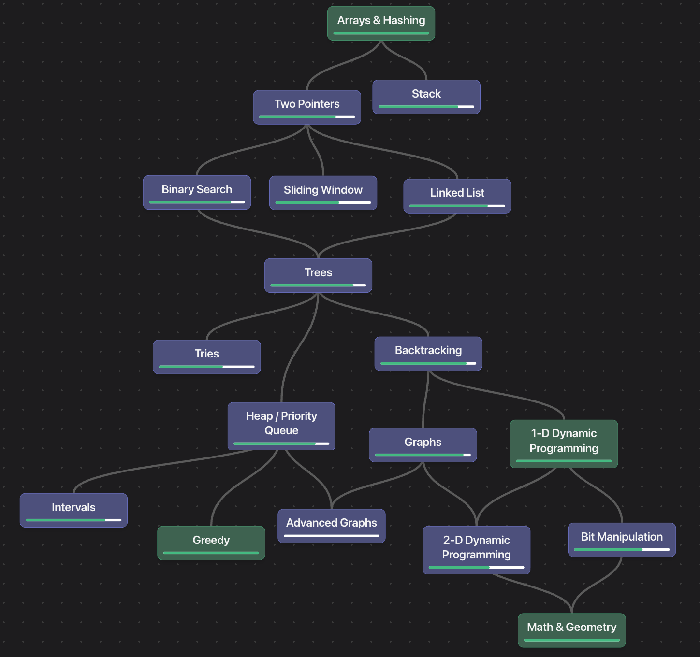
Readiness. A topic is ready when its mastery is at least 0.65 over at least 3 answers. Mastery is recency-weighted accuracy (weight 0.9 per older answer, last 20 answers) smoothed with a Beta(1,1) prior, so one lucky answer does not count as mastery. A topic unlocks when all of its prerequisites are ready; Arrays & Hashing is the root.
Recommendation (graph-v1). Target topics are (a) topics missed today (extra practice only), (b) weak topics below 0.65, (c) unlocked topics with fewer than 3 answers, and (d) the roadmap frontier. If a target is locked, its unready prerequisites are practiced instead. Candidates exclude questions already served today and questions answered correctly in the last 3 days. Daily sets prefer unseen questions. Candidates are ranked by six features — weakness (0.25), missed today (0.25), prerequisite gap (0.15), novelty (0.15), difficulty fit (0.10) and staleness (0.10) — and diversified to at most 2 per topic. Scores, features and reasons are logged, and the reason is shown to the learner in the quiz menu.

8 Datasets and question ingestion

Initial dataset
Seed a small reviewed collection of Amazon-tagged algorithm questions with enough foundational coverage to support the topic graph. A proposed pilot is 50 questions across 8–12 topics, adjusted to content availability and review capacity. Keep external question identifiers, source links, difficulty labels, company-tag provenance, and observation dates. Company tags may be incomplete or stale; make their provenance visible.
Use source material the project has permission to store and display. Where full problem text is unavailable for reuse, store an original summary and a link to the source. Do not build ingestion around bypassing restricted access. Maintain a source manifest with permitted fields, provenance, refresh policy, and an owner responsible for reviewing content availability.

Ingestion pipeline
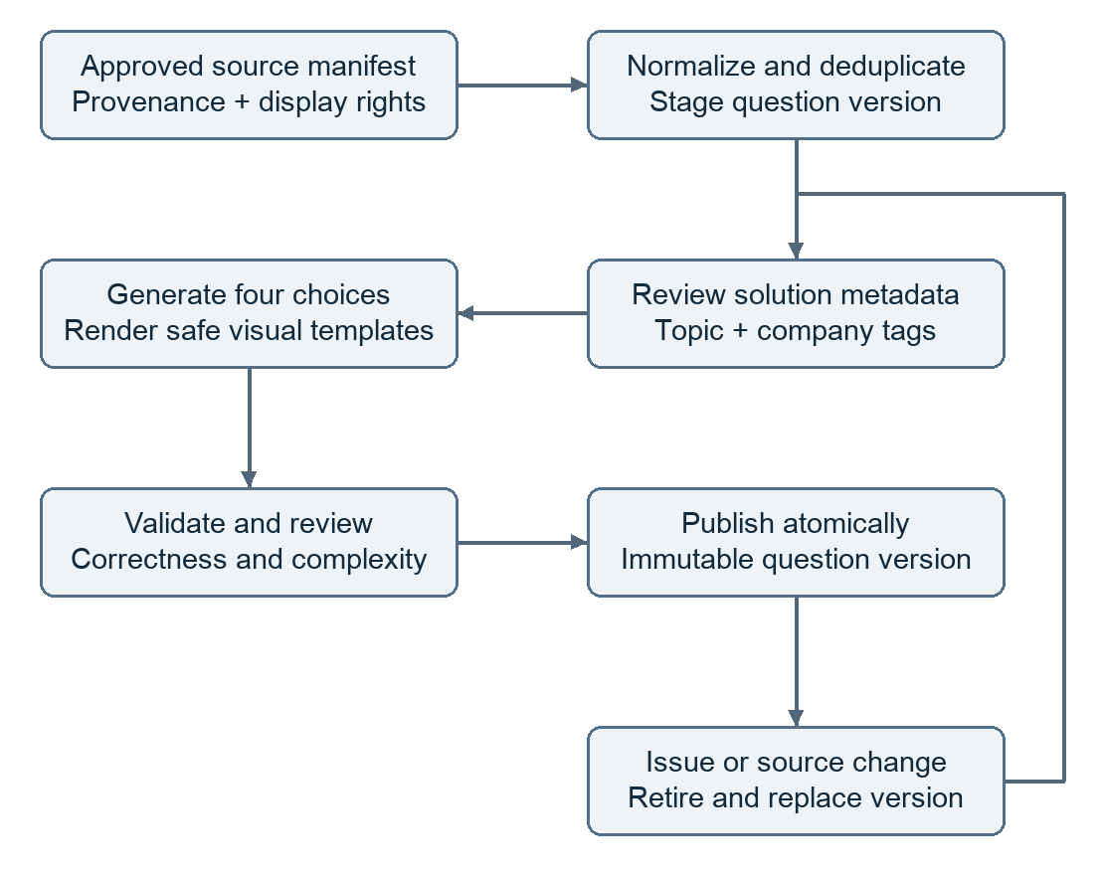

10 Evaluation security and validation
Area | Measurement and proposed release gate
Learning outcomes | Track seven-day return rate, weekly active learners and completion. Measure first-exposure accuracy on held-out related questions; compare adaptive ranking with difficulty-matched random practice before claiming learning lift.
Operations | Proposed p95 targets: ordinary reads and performance under 100 ms, recommendations under 1 s. Benchmark with 50 concurrent learners; track error, fallback and per-active-user LLM cost.

Future version
V2
- Broader companies and topic coverage
- GraphRAG, MCP

